**p5.js Tutorial by Daniel Shiffman**

**Sarah Zaheer**

# **Michael Toren**

1. **What do the numbers inside the parentheses after a function name do?**

*The numbers inside the parentheses provide parameters to help the computer understand how to follow the given instructions.*

1. **What’s the difference between fill and stroke?**

*If we have a rectangular canvas and the shape one chooses to draw is an ellipse with ellipse function,fill describes the interior of that shape and stroke describes the outline of the shape.*

1. **The p5 web editor has a built-in console — but it turns out that Chrome also has a console to display errors. Do some googling to find out how you can open the Chrome console. Then, try to find a website that has errors — visit a website, open the console, and see if there are any red-highlighted items. Take a screenshot and upload it into your repository.**

*Etsy.com*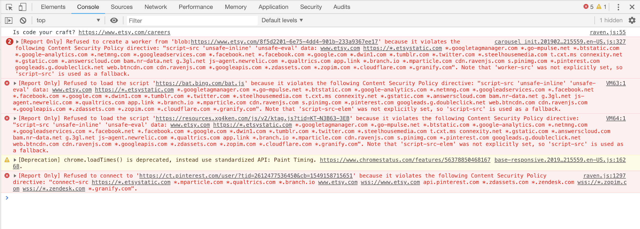

1. **What is the keyboard shortcut to open the JavaScript console in Chrome on your system?**

*Option+Command+J*